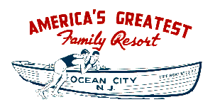

«_stxfirst» «_stxlast»
«_stxaddr»
«_stxcity», «_stxstate» «_stxzip»

The best Internet address for your Ocean City, NJ business is:
-
OceanCityNJ.com, Another AtTheBeach.com Site!

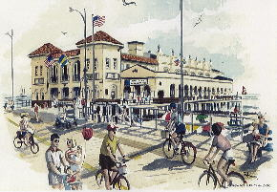 | Real Estate  Vacation Rentals  Sale Listings  Search Sale Listings  Tax Records  Mortgage Calculation  Other  Live Downtown  Other Links  Send an Ocean City Postcard


For advertising information:

lisa@AtTheBeach.com

(609) 399-7514

Food Shop Events Rooms House Art Service Fun Local All

