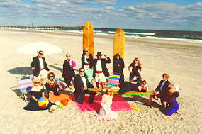
Surf's UP!

«_stxfirst» «_stxlast»
«_stxaddr»
«_stxcity», «_stxstate» «_stxzip»

The best Internet address for Ocean City, NJ Real Estate is:

OCJB.com
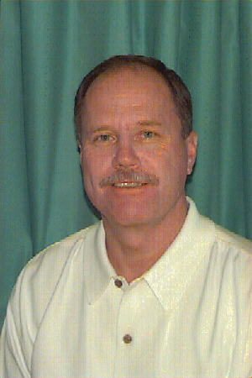 | Please try:  Sale Listings  Vacation Rental Search  Send an Ocean City Postcard  Mortgage Calculation  Investment Property Analysis  Email me  About Jim Bourgeois  Welcome to my personal web site. One of the most important steps when purchasing or selling real estate is choosing your real estate agent.  I have been Ocean City's #1 sales agent for the last 13 years with over 20 years experience and over $250 million in personal sales volume. I am committed to total customer service and satisfaction.  When it comes to buying, selling or renting call Hager Real Estate's Jim Bourgeois at:  (800) 220-6265


Hager Real Estate, Inc.

Jim Bourgeois

(800) 220-6265 or (609) 399-0041

jlb@OCNJ.com

421 Battersea Road

P.O. Box 597

Ocean City, NJ 08226-0597

Food Shop Events Rooms House Art Service Fun Local All

