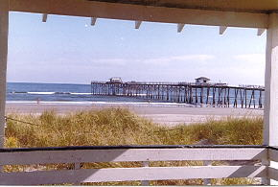
Life’s
a
Beach!

«_stxfirst» «_stxlast»
«_stxaddr»
«_stxcity», «_stxstate» «_stxzip»

RE: 418 49th Street, Ocean City

Dear «_stxsalu»:

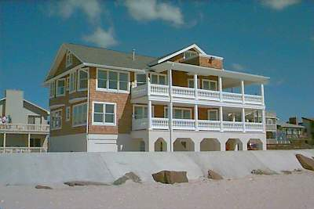
“A picture’s worth a thousand words”, and this is it:

The best priced single family on the market in the Ocean City area.

Call:
(888) Jim-Ginn
for details!

Sincerely,

Jim Ginn

